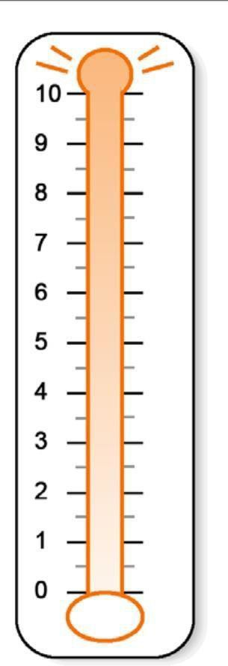
FIGURE 2: THE DISTRESS THERMOMETER

Extreme

None

