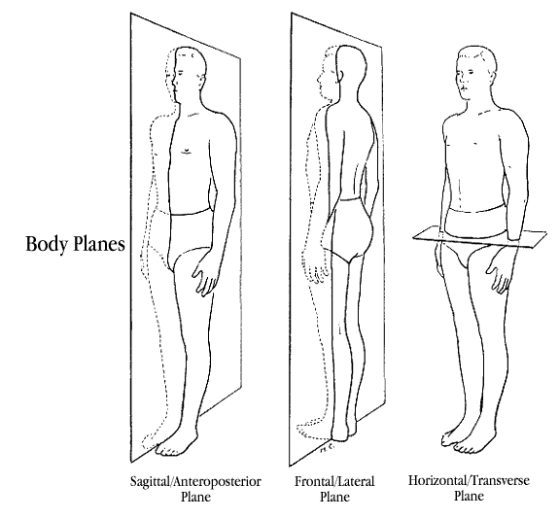

TRANSVERSE

FRONTAL

SAGITTAL

**Sagittal Plane**

The Sagittal plane passes through the body front to back, so dividing it into left and right. Movements in this plane include the up and down movements of spinal flexion and extension and knee lifts

**Frontal Plane (aka Coronal Plane)**

The frontal plane divides the body into front and back. Movements in this plane are sideways movements such as abduction and adduction and lateral flexion (side bends)

**Transverse Plane**

This plane divides the body into top and bottom. Movements in this plane are rotational in nature, such as spine twists (also internal and external rotation, pronation and supination)