MSE
Music BPM 125-130

Music counts / reps / sets | Exercise | Teaching / coaching points | Progressions (H) – regressions (E) – any other modification or adaptions (optional)
Group to grab a a mat each. Make sure people are in a suitable place – all facing me or facing the centre of the room. Can they see me?
ABDOMINAL CURLS

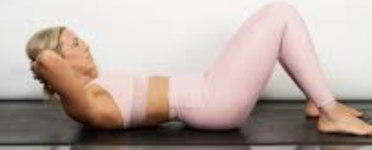

PRESS UPS

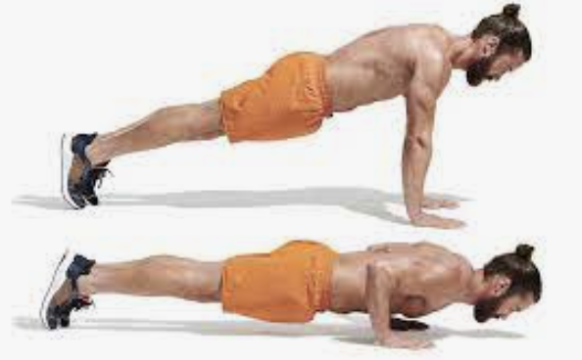

DORSAL RAISES

