Health and safety in a group training environment
Unit accreditation number: H/617/1109

Worksheet – Health and safety in a group training environment

There are 35 marks available in this worksheet. You must score a minimum of 28 marks in total to achieve a Pass. In addition to achieving the total Pass mark, you must also score at least the minimum marks set for each question to achieve an overall Pass.
- Outline two responsibilities of employers and two rights and two responsibilities of employees in the workplace.

Responsibilities of employers | Rights of employees | Responsibilities of employees
6 marks (minimum 4 marks)

- Outline one health and safety and one insurance requirement when hiring venues or facilities.

Health and safety

Insurance
2 marks (minimum 2 marks)

- Explain the following terms in relation to health and safety in the workplace.

Duty of care

Hazard

Risk

3 marks (minimum 2 marks)

- Identify two key legal and regulatory requirements that are relevant to health and safety in the workplace.

2 marks (minimum 1 mark)

- Describe what may happen if employers and employees do not follow the legal requirements of health and safety.

1 mark (minimum 1 mark)

- State the importance of having Normal Operating Procedures (NOPs) and Emergency Action Plans (EAPs) and describe a key area that should be included in each.

 | NOPs | EAPs
Importance
A key area that should be included
4 marks (minimum 3 marks)

- Explain the importance of safely storing and maintaining equipment.
1 mark (minimum 1 mark)

- Consider the following scenario: You are preparing the studio for your group training class and are on the lookout for possible hazards that might pose a risk to customers, staff and other visitors.

Task 1
Identify four hazards in the image below (circle as appropriate).

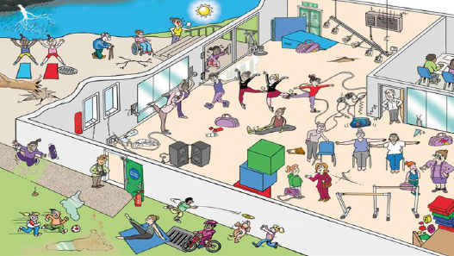

If you cannot circle the hazard then you can identify it by describing it in the box below

4 marks (minimum 3 marks)

Task 2
Choose one of the hazards identified in Task 1 and complete a risk assessment:
- Identifying the five stages of a risk assessment.
- Relating them to the identified hazard.
- Explaining how the risk of the hazard can be eliminated or reduced.

Risk-assessment stage (identify each one) | Hazard
1

2

3

4

5
How should the risk be managed?

6 marks (minimum 4 marks)

Task 3
List three pieces of equipment likely to be found in a group training environment and describe the appropriate checks required to ensure safety and cleanliness.
Equipment | Safety and cleanliness checks
6 marks (minimum 4 marks)
Results total /35 marks (28 marks in total, with the minimum set marks achieved for each question required to pass)
Pass/Refer

