**Spotting Technique general guidelines**

The spotter should use a widened split stance to create a larger base of stability

The torso should be upright, and the hands should be in a position that most effectively spots the specific exercise.

If it is an exercise such as the bench press, the spotter should consider an alternating grip for extra safety

If it is an exercise such as a dumbbell shoulder press, then the spotter could place both hands on the lifter's wrists or forearms to provide support.

The spotter must be able to lift the entire weight of the bar or dumbbells. It is acceptable to use two spotters if required.

If the instructor is not able to spot and there is any doubt about the safety of a lift then a machine should be used – or the client should use a weight well within their capability.

**SELF SPOTTING**

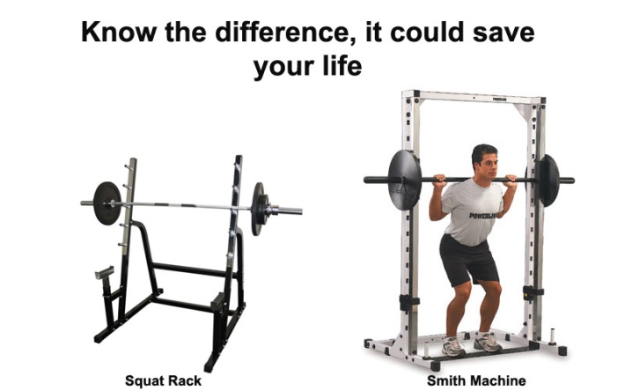***The squat rack*** can be used as it allows for a *relatively* safe free-weight workout. Bar catchers are used to stop the barbell in the event of an emergency. There are no restrictions to the movement of the lift – but some risk remains. Clients should not rely on a squat rack and should use spotters or lift weights well within their range.

***Smith machines*** have guide channels for the bar and pins to prevent the bar from dropping below a certain height. The bar travels on a fixed path.

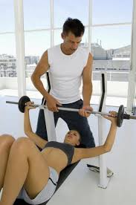**Usual Sequence for spotting a bench press**

* Check client is in a stable position on the bench
* Spotter deadlifts the bar (or dumbbells)
* Client extends arms over crown of head (away from face)
* Spotter steps in and both spotter and client hold the bar (optional use of the phrase “spotter in”)
* Spotter then takes a step forward with a slight upright row allowing the bar to move over the client’s chest
* Instruct the client (when they feel confident that they have hold of the bar) to say “My Bar”
* Spotter allows client to take the bar but stays in position with an alternating hand position
* This allows the spotter to be ready to move in and assist or take the bar should the client get into difficulty.
* The spotter can perform a lunge squat as the bar rises and lowers
* Client then should say “I have finished the Exercise” – or the spotter can tell the client “last rep”.
* Spotter moves back into a closer position – arms in slight upright row position
* Both client and spotter keep control of the bar and take it overhead away from the head and body
* When client is happy the bar is away from his/her head client says “Your Bar”
* Spotter steps away and deadlifts the bar to the floor.

If there is a suitable rack then a client can self-spot.

**Spotting a back squat**

* 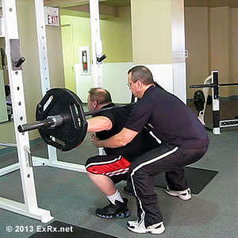Client will clean the bar into position (or take it from a squat rack)
* Spotter stands behind the client so that they can use their own arms to help the client to stand up should they get into difficulty.
* Not commonly used due to body positioning. Best to have two people at either end of the bar.

**Guidance on lifting/passing dumbbells**

Generally speaking, you should not pass dumbbells to your client. You should show the client how to pick them up from the rack or floor. If you pass the dumbbells to your client with them in an “exercise ready” position, they could be unbalanced.

**Guidance on lifting/passing barbells**

Ideally your client should be able to safely deadlift a barbell and then clean and press for e.g. a back squat. The client could take the bar from a suitable rack to perform a back squat. If your client is performing a bench press without a rack then you can spot the bar into position.

***Spotting is clearly a huge responsibility!***

***Both instructor and client must have their own safety as the No 1 priority.***

***Clear communication throughout is essential***